****If you want to remote control the car by Bluetooth APP, you need to complete the following steps.****

1. ****!!!Note:Please do not use the microbit online programming to open the Bluetooth program, otherwise there will be an error. If you want to use the Bluetooth remote control, please directly copy the hex file we provided to the microbit U disk.****
2. Android users search "Hellobot" in Play Store to download APP.

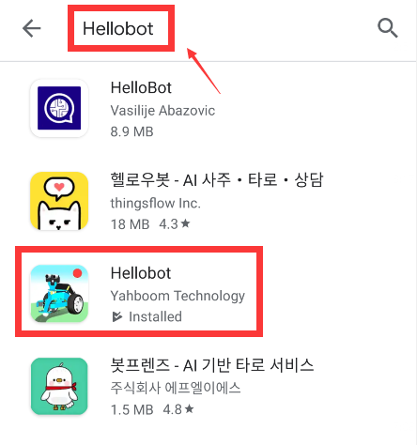

1. Download the Bluetooth remote control code we provided to the Micro:bit board.

**Case1:** If your HelloBot is a Basic version HelloBot robot, you need to download the Bluetooth program **[Basic version Bluetooth control];**

**Case2:** If your car is a Clip version HelloBot robot, please download the Bluetooth program **[Clip version Bluetooth control];**

**Case3:** If your car is a Lift version HelloBot robot, please download the Bluetooth program **[Lift version Bluetooth control].**

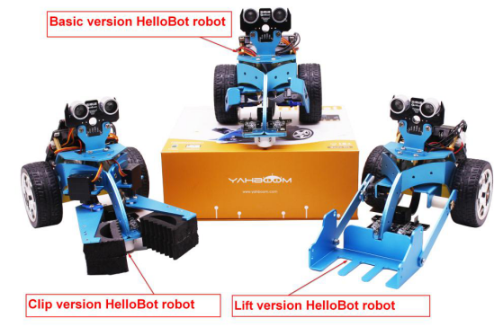

1. At this time, you should open the mobile phone Bluetooth and open the application [HelloBot], if prompted some message please click [Allow], as shown below. Otherwise you will not be able to use this application.

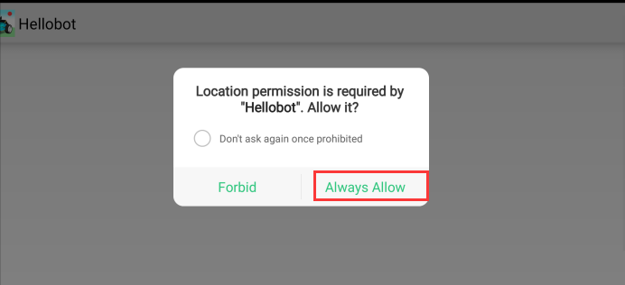

1. Bluetooth is automatically connected when the mobile phone is near the robot. And the indicator light of the Bluetooth module is not flashing after the connection is successful.
2. After successful connection,enter the main control page.

Part 1:

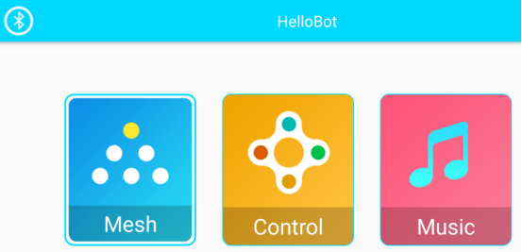

Part 2:

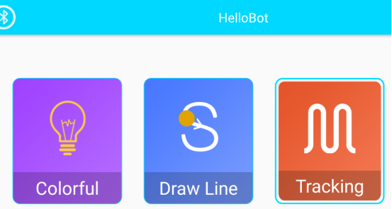

Part 3:

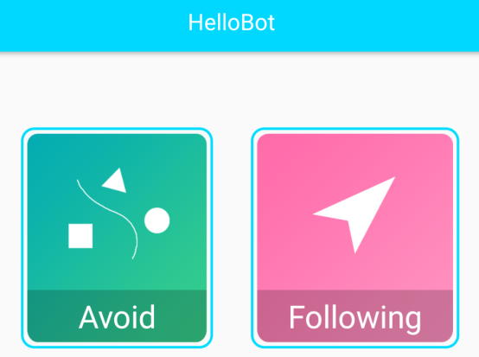

1. You can select following option

****7--1 Mesh****

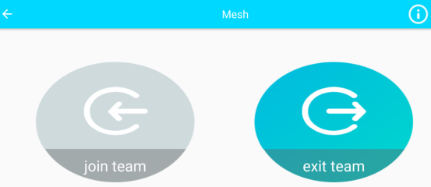

When multiple HelloBot cars download the Bluetooth program, click****“join team”****to enter the formation. All the colorful lights of the car are green, indicating that the formation is successful. You can directly control the car to completesome actions, or you can directly click ****“exit team”****to leave the formation.

**7**--2 Control****

When controlling, you can choose three versions:

****clamp(clip version),forklift(lift version),arm(Basic version).****

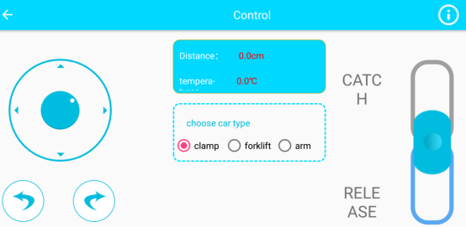

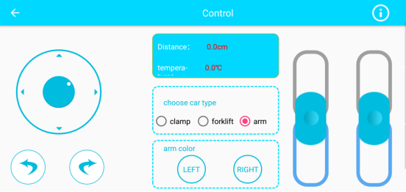

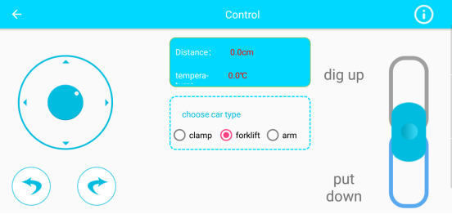

****7--3 Music****

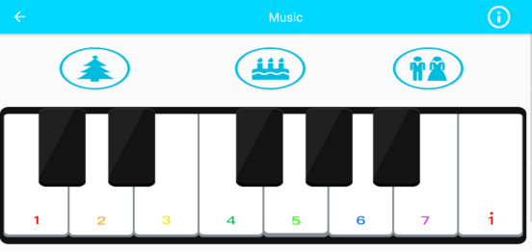

****7--4 Draw Line****

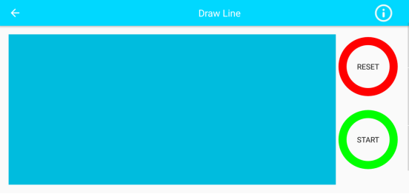

**7--5 Mode choice**

